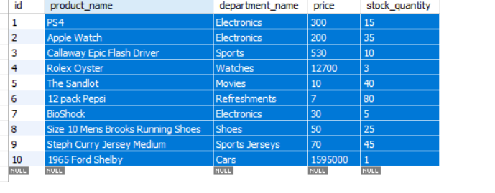

19109@DESKTOP-8CFR9VC MINGW64 ~/desktop/UNC BOOTCAMP/CLI-app (master)

$ node bamazoncustomer.js

connected as id 143

[ RowDataPacket {

id: 1,

product_name: 'PS4',

department_name: 'Electronics',

price: 300,

stock_quantity: 15 },

RowDataPacket {

id: 2,

product_name: 'Apple Watch',

department_name: 'Electronics',

price: 200,

stock_quantity: 35 },

RowDataPacket {

id: 3,

product_name: 'Callaway Epic Flash Driver',

department_name: 'Sports',

price: 530,

stock_quantity: 10 },

RowDataPacket {

id: 4,

product_name: 'Rolex Oyster',

department_name: 'Watches',

price: 12700,

stock_quantity: 3 },

RowDataPacket {

id: 5,

product_name: 'The Sandlot',

department_name: 'Movies',

price: 10,

stock_quantity: 40 },

RowDataPacket {

id: 6,

product_name: '12 pack Pepsi',

department_name: 'Refreshments',

price: 7,

stock_quantity: 80 },

RowDataPacket {

id: 7,

product_name: 'BioShock',

department_name: 'Electronics',

price: 30,

stock_quantity: 5 },

RowDataPacket {

id: 8,

product_name: 'Size 10 Mens Brooks Running Shoes',

department_name: 'Shoes',

price: 50,

stock_quantity: 25 },

RowDataPacket {

id: 9,

product_name: 'Steph Curry Jersey Medium',

department_name: 'Sports Jerseys',

price: 70,

stock_quantity: 45 },

RowDataPacket {

id: 10,

product_name: '1965 Ford Shelby',

department_name: 'Cars',

price: 1595000,

stock_quantity: 1 } ]

stock_quantity: 1 } ]

? What would you like to buy??

EXIT

PS4

Apple Watch

> Callaway Epic Flash Driver

Rolex Oyster

The Sandlot

12 pack Pepsi

(Move up and down to reveal more choices)

C:\Users\19109\desktop\UNC BOOTCAMP\CLI-app\node_modules\mysql\lib\protocol\Parser.js:437

throw err; // Rethrow non-MySQL errors

^

ReferenceError: stock_quantity is not defined

at Query. (C:\Users\19109\desktop\UNC BOOTCAMP\CLI-app\bamazoncustomer.js:68:37)

at Query. (C:\Users\19109\desktop\UNC BOOTCAMP\CLI-app\node_modules\mysql\lib\Connection.js:525:10)

at Query._callback (C:\Users\19109\desktop\UNC BOOTCAMP\CLI-app\node_modules\mysql\lib\Connection.js:491:16)

at Query.Sequence.end (C:\Users\19109\desktop\UNC BOOTCAMP\CLI-app\node_modules\mysql\lib\protocol\sequences\Sequence.js:83:24)

at Query._handleFinalResultPacket (C:\Users\19109\desktop\UNC BOOTCAMP\CLI-app\node_modules\mysql\lib\protocol\sequences\Query.js:139:8)

at Query.EofPacket (C:\Users\19109\desktop\UNC BOOTCAMP\CLI-app\node_modules\mysql\lib\protocol\sequences\Query.js:123:8)

at Protocol._parsePacket (C:\Users\19109\desktop\UNC BOOTCAMP\CLI-app\node_modules\mysql\lib\protocol\Protocol.js:291:23)

at Parser._parsePacket (C:\Users\19109\desktop\UNC BOOTCAMP\CLI-app\node_modules\mysql\lib\protocol\Parser.js:433:10)

at Parser.write (C:\Users\19109\desktop\UNC BOOTCAMP\CLI-app\node_modules\mysql\lib\protocol\Parser.js:43:10)

at Protocol.write (C:\Users\19109\desktop\UNC BOOTCAMP\CLI-app\node_modules\mysql\lib\protocol\Protocol.js:38:16)

? What would you like to buy?? PS4

? How many units would you like? 1

Great Option

leaving store

working

order is now complete! Have a nice day!

order is now complete! Have a nice day!

order is now complete! Have a nice day!

order is now complete! Have a nice day!

order is now complete! Have a nice day!

order is now complete! Have a nice day!

order is now complete! Have a nice day!

order is now complete! Have a nice day!

order is now complete! Have a nice day!

order is now complete! Have a nice day!